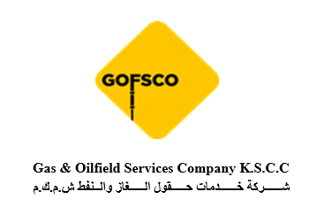
AI-Driven Production Diagnostic & Interpretation Platform
Technical Project Overview
Prepared By: Gas & Oilfield Services Company K.S.C.C. (GOFSCO)
Project Lead: Ali Adel Jafarian

Executive Summary
The AI-Driven Production Diagnostic & Interpretation Platform is an ongoing technology development initiative aimed at enhancing production diagnostics, artificial lift analysis, and operational decision support through the integration of multiple oilfield datasets into a unified analytical environment.

1. Project Background
Modern oilfield operations generate significant volumes of operational and surveillance data from multiple sources. The platform seeks to create a centralized environment where production, wireline, and artificial lift data can be evaluated simultaneously using AI-assisted analytical methods.

2. Project Objectives
• Integrate production, wireline, and artificial lift datasets.
• Improve engineering visibility.
• Support faster interpretation workflows.
• Identify anomalies earlier.
• Utilize historical field data for pattern recognition.
• Establish a foundation for future predictive analytics.

3. Data Sources
Production Data: Oil, water, gas rates, watercut, historical performance.
Wireline Data: PLT, temperature, spinner, pressure surveys, flow profiles.
Artificial Lift Data: ESP telemetry, voltage, current, frequency, intake/discharge pressures, PCP data.
Additional Data: Historical records, intervention history, equipment performance.


4. Platform Methodology
Stage 1 – Data Acquisition & Integration
Stage 2 – Data Validation & Quality Control
Stage 3 – AI-Assisted Analysis
Stage 4 – Engineering Interpretation Support

5. Core Functionalities
• Multi-Source Data Correlation
• Historical Pattern Recognition
• AI-Assisted Anomaly Detection
• Artificial Lift Diagnostics
• Wireline Interpretation Support

6. Expected Benefits
• Faster interpretation workflows
• Improved operational visibility
• Better integration of production and lift data
• Earlier anomaly identification
• Improved engineering efficiency
• Reduced manual data correlation effort

7. Future Development Roadmap
• Advanced predictive analytics
• Expanded historical pattern libraries
• Field-wide production intelligence
• Reservoir-area analysis concepts
• Injector–Producer Influence Scoring concepts

8. Current Project Status
Prototype and development stage. Current efforts focus on software stabilization, workflow refinement, data integration expansion, user interface improvement, validation planning, and pilot implementation strategies.

9. Conclusion
The platform is intended to provide a practical and scalable engineering support environment that improves diagnostic efficiency, operational awareness, and future digital transformation initiatives while maintaining engineering oversight.

